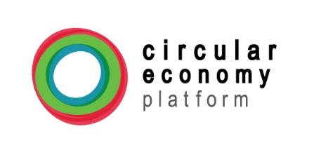
Member Information
Organization name:
Organization address (include country):
Type of organization (select one):
 | Corporation |  | NGO, Foundation |  | Government |  | University |  | Association |  | Other
If other, please specify:

Organization profile (5 lines) – Please describe your main activities related to circular economy

_____________________________________________________________________________________________________
Contact information
Full Name of contact person:
E-mail Address:
Phone number:
Position:
_____________________________________________________________________________________________________
Membership selection – Please select your membership option
 | Bronze (2.5000USD/year) |  | Silver(5.000USD/year) |  | Gold (7.500USD/year)

Member Profile - Organizations

Please complete this form and return it to Mrs. Lorena García (CEP-Americas Manager), along with a JPEG image of your organization’s logo (to be uploaded on CEP-Americas’ website).
Email: info@cep-americas.com

